**Bluetooth**

**Introduction:** "Bluetooth" was the nickname of HaraldBlåtland II, king of Denmark from 940 to 981, who united all of Denmark and part of Norway under his rule. **Bluetooth**is a proprietary open wireless technology standard for exchanging data over short distances (using short wavelength radio transmissions in the ISM band from 2400-2480 MHz) from fixed and mobile devices, creating personal area networks (PANs) with high levels of security. The Bluetooth technology aims at so-called **ad-hoc piconets**, which are local area networks with a very limited coverage and without the need for an infrastructure.

**Bluetooth Features**

1. Bluetooth is wireless and automatic. You don't have to keep track of cables, connectors, and connections, and you don't need to do anything special to initiate communications. Devices find each other automatically and start conversing without user input, expect where authentication is required; for example, users must log in to use their email accounts.
2. Bluetooth is inexpensive. Market analysts peg the cost to incorporate Bluetooth technology into a PDA, cell phone, or other product at a minimum cost.
3. The ISM band that Bluetooth uses is regulated, but unlicensed. Governments have converged on a single standard, so it's possible to use the same devices virtually wherever you travel, and you don't need to obtain legal permission in advance to begin using the technology.
4. Bluetooth handles both data and voice. Its ability to handle both kinds of transmissions simultaneously makes possible such innovations as a mobile hands-free headset for voice with applications that print to fax, and that synchronize the address books on your PDA, your laptop, and your cell phone.
5. Signals are omni-directional and can pass through walls and briefcases. Communicating devices don't need to be aligned and don't need an unobstructed line of sight like infrared.
6. Bluetooth uses frequency hopping. Its spread spectrum approach greatly reduces the risk that communications will be intercepted.

**Bluetooth Applications**

1.  File transfer.

2. Ad-hoc networking: Communicating devices can spontaneously form a community of networks that persists only as long as it's needed

3. Device synchronization: Seamless connectivity among PDAs, computers, and mobile phones allows applications to update information on multiple devices automatically when data on any one device changes.

4. Peripheral connectivity.

5. Car kits: Hands-free packages enable users to access phones and other devices without taking their hands off the steering wheel

6. Mobile payments: Your Bluetooth-enabled phone can communicate with a Bluetooth-enabled vending machine to buy a can of Diet Pepsi, and put the charge on your phone bill.

The 802.11b protocol is designed to connect relatively large devices with lots of power and speed, such as desktops and laptops, where devices communicate at up to 11 Mbit/sec, at greater distances (up to 300 feet, or 100 meters). By contrast, Bluetooth is designed to connect small devices like PDAs, mobile phones, and peripherals at slower speeds (1 Mbit/sec), within a shorter range (30 feet, or 10 meters), which reduces power requirements. Another major difference is that 802.11b wasn't designed for voice communications, while any Bluetooth connection can support both data and voice communications.

**Networking in Bluetooth**

**Introduction:** Bluetooth operates on 79 channels in the 2.4 GHz band with 1 MHz carrier spacing. Each device performs frequency hopping with 1,600 hops/s in a pseudo random fashion. A piconet is a collection of Bluetooth devices which are synchronized to the same hopping sequence. One device in the piconet can act as **master**(M), all other devices connected to the master must act as **slaves**(S). The master determines the hopping pattern in the piconet and the slaves have to synchronize to this pattern. Each piconet has a unique hopping pattern. If a device wants to participate it has to synchronize to this. A typical piconet is shown below:

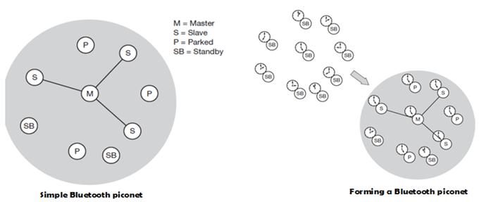

Parked devices (P) cannot actively participate in the piconet (i.e., they do not have a connection), but are known and can be reactivated within some milliseconds. Devices in stand-by (SB) do not participate in the piconet. Each piconet has exactly one master and up to seven simultaneous slaves. More than 200 devices can be parked. The first step in forming a piconet involves a master sending its clock and device ID. All the Bluetooth devices have the same capability to become a master or a slave and two or three devices are sufficient to form a piconet. The unit establishing the piconet automatically becomes the master, all other devices will be slaves. The hopping pattern is determined by the device ID, a 48-bit worldwide unique identifier.

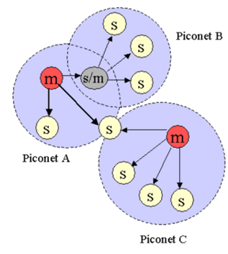

The phase in the hopping pattern is determined by the master’s clock. After adjusting the internal clock according to the master a device may participate in the piconet. All active devices are assigned a 3-bit **active member address**(AMA). All parked devices use an 8-bit **parked member address**(PMA). Devices in stand-by do not need an address.

A device in one piconet can communicate to another device in another piconet, forming a **scatternet**. A master in one piconet may be a slave in another piconet. Both piconets use a different hopping sequence, always determined by the master of the piconet. Bluetooth applies **FH-CDMA**for separation of piconets. A collision occurs if two or more piconets use the same carrier frequency at the same time. This will probably happen as the hopping sequences are not coordinated. If a device wants to participate in more than one piconet, it has to synchronize to the hopping sequence of the piconet it wants to take part in. If a device acts as slave in one piconet, it simply starts to synchronize with the hopping sequence of the piconet it wants to join. After synchronization, it acts as a slave in this piconet and no longer participates in its former piconet. To enable synchronization, a slave has to know the identity of the master that determines the hopping sequence of a piconet. Before leaving one piconet, a slave informs the current master that it will be unavailable for a certain amount of time. The remaining devices in the piconet continue to communicate as usual.

**Bluetooth Protocol Stack**

**Introduction:** The Bluetooth protocol stack can be divided into a core specification, which describes the protocols from physical layer to the data link control together with management functions, and profile specifications describing many protocols and functions needed to adapt the wireless Bluetooth technology to legacy and new applications.

A high-level view of the architecture is shown. The responsibilities of the layers in this stack are as follows:

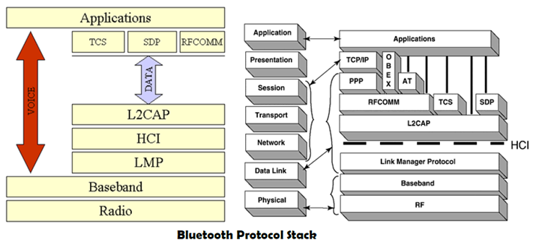

1. The radio layer is the physical wireless connection. To avoid interference with other devices that communicate in the ISM band, the modulation is based on fast frequency hopping. Bluetooth divides the 2.4 GHz frequency band into 79 channels 1 MHz apart (from 2.402 to 2.480 GHz), and uses this spread spectrum to hop from one channel to another, up to 1600times a second. The standard wavelength range is 10 cm to 10 m, and can be extended to 100 m by increasing transmission power.
2. The baseband layer is responsible for controlling and sending data packets over the radio link. It provides transmission channels for both data and voice. The baseband layer maintains Synchronous Connection-Oriented (SCO) links for voice and Asynchronous Connectionless (ACL) links for data. SCO packets are never retransmitted but ACL packets are, to ensure data integrity. SCO links are point-to-point symmetric connections, where time slots are reserved to guarantee timely transmission. A slave device is allowed to respond during the time slot immediately following an SCO transmission from the master. A master can support up to three SCO links to a single slave or to multiple slaves, and a single slave can support up to two SCO links to different slaves. Data transmissions on ACL links, on the other hand, are established on a per-slot basis (using slots not reserved for SCO links). ACL links support point-to-multipoint transmissions. After an ACL transmission from the master, only a slave addressed specifically may respond during the next time slot; if no device is addressed, the message is treated as a broadcast.
3. The Link Manager Protocol (LMP) uses the links set up by the baseband to establish connections and manage piconets. Responsibilities of the LMP also include authentication and security services, and monitoring of service quality.
4. The Host Controller Interface (HCI) is the dividing line between software and hardware. The L2CAP and layers above it are currently implemented in software, and the LMP and lower layers are in hardware. The HCI is the driver interface for the physical bus that connects these two components. The HCI may not be required. The L2CAP may be accessed directlyby the application, or through certain support protocols provided to ease the burden on application programmers.
5. The Logical Link Control and Adaptation Protocol (L2CAP) receive application data and adapts it to the Bluetooth format. Quality of Service (QoS) parameters is exchanged at this layer.

**Link Manager Protocol for Bluetooth**

**Introduction:** The link manager protocol (LMP) manages various aspects of the radio link between a master and a slave and the current parameter setting of the devices. LMP enhances baseband functionality, but higher layers can still directly access the baseband. **The following groups of functions are covered by the LMP:**

**Authentication, pairing, and encryption**: Although basic authentication is handled in the baseband, LMP has to control the exchange of random numbers and signed responses. LMP is not directly involved in the encryption process, but sets the encryption mode (no encryption, point-to-point, or broadcast), key size, and random speed.

**Synchronization**: Precise synchronization is of major importance within a Bluetooth network. The clock offset is updated each time a packet is received from the master.

**Capability negotiation**: Not only the version of the LMP can be exchanged but also information about the supported features. Not all Bluetooth devices will support all features that are described in the standard, so devices have to agree the usage of, e.g., multi-slot packets, encryption, SCO links, voice encoding, park/sniff/hold mode, HV2/HV3 packets etc.

**Quality of service negotiation**: Different parameters control the QoS of a Bluetooth device at these lower layers. The poll interval, i.e., the maximum time between transmissions from a master to a particular slave, controls the latency and transfer capacity. A master can also limit the number of slots available for slaves’ answers to increase its own bandwidth.

**Power control:** A Bluetooth device can measure the received signal strength. Depending on this signal level the device can direct the sender of the measured signal to increase or decrease its transmit power.

**Link supervision**: LMP has to control the activity of a link, it may set up new SCO links, or it may declare the failure of a link.

**State and transmission mode change:** Devices might switch the master/slave role, detach themselves from a connection, or change the operating mode

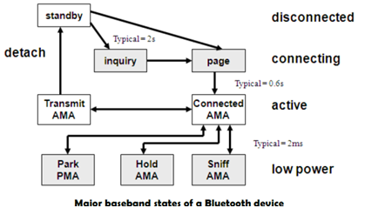

Bluetooth defines several low-power states for a device. The following figure shows the major states of a Bluetooth device and typical transitions. Every device, which is currently not participating in a piconet (and not switched off), is in standby mode. This is a low-power mode where only the native clock is running. The next step towards the inquiry mode can happen in two different ways. Either a device wants to establish a piconet or a device just wants to listen to see if something is going on.

* A device wants to establish a piconet: A user of the device wants to scan for other devices in the radio range. The device starts the inquiry procedure by sending an inquiry access code (IAC) that is common to all Bluetooth devices. The IAC is broadcast over 32 so-called wake-up carriers in turn.
* Devices in standby that listen periodically: Devices in standby may enter the inquiry mode periodically to search for IAC messages on the wake-up carriers. As soon as a device detects an inquiry it returns a packet containing its device address and timing information required by the master to initiate a connection. From that moment on, the device acts as slave.

If the inquiry was successful, a device enters the page mode. The inquiry phase is not coordinated, so it may take a while before the inquiry is successful. After a while, a Bluetooth device sees all the devices in its radio range.

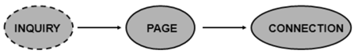

During the **page**state two different roles are defined. After finding all required devices the master is able to set up connections to each device, i.e., setting up a piconet. As soon as a device synchronizes to the hopping pattern of the piconet it also enters the connection state. The connection state comprises the active state and the low power states: **park, sniff,**and **hold.**In the **active**state the slave participates in the piconet by listening, transmitting, and receiving. ACL and SCO links can be used. A master periodically synchronizes with all slaves. All devices being active must have the 3-bit **active member address**(AMA). To save battery power, a **Bluetooth device can go into one of three low power states:**

**Sniff state:**The sniff state has the highest power consumption of the low power states. Here, the device listens to the piconet at a reduced rate (not on every other slot as is the case in the active state). The interval for listening into the medium can be programed and is application dependent. The master designates a reduced number of slots for transmission to slaves in sniff state. However, the device keeps its AMA.

**Hold state:**The device does not release its AMA but stops ACL transmission. A slave may still exchange SCO packets. If there is no activity in the piconet, the slave may either reduce power consumption or participate in another piconet.

**Park state:**In this state the device has the lowest duty cycle and the lowest power consumption. The device releases its AMA and receives a parked member address (PMA). The device is still a member of the piconet, but gives room for another device to become active (AMA is only 3 bit, PMA 8 bit). Parked devices are still FH synchronized and wake up at certain beacon intervals for re-synchronization. All PDUs sent to parked slaves are broadcast

**L2CAP(logical link control and adaptation protocol)**

**Introduction:** The logical link control and adaptation protocol (L2CAP) is a data link control protocol on top of the baseband layer offering logical channels between Bluetooth devices with QoS properties. L2CAP is available for ACLs only.

**L2CAP provides three different types of logical channels that are transported via the ACL between master and slave:**

**Connectionless:** These unidirectional channels are typically used for broadcasts from a master to its slave(s).

**Connection-oriented:** Each channel of this type is bi-directional and supports QoS flow specifications for each direction. These flow specs follow RFC 1363 and define average/peak data rate, maximum burst size, latency, and jitter.

**Signaling:** This third type of logical channel is used to exchanging signaling messagesbetween L2CAP entities.

Each channel can be identified by its channel identifier (CID). Signaling channels always use a CID value of 1, a CID value of 2 is reserved for connectionless channels. For connection-oriented channels a unique CID (>= 64) is dynamically assigned at each end of the channel to identify the connection.

**The following figure shows the three packet types belonging to the three logical channel types.**

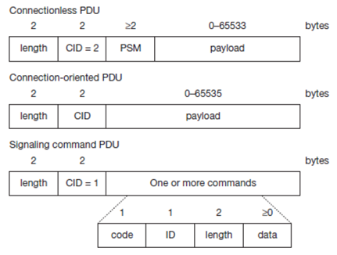

The **length**field indicates the length of the payload (plus PSM for connectionless PDUs). The **CID**has the multiplexing/de-multiplexing function. For connectionless PDUs a **protocol/service multiplexor (PSM)**field is needed to identify the higher layer recipient for the payload. For connection-oriented PDUs the CID already fulfills this function. Several PSM values have been defined, e.g., 1 (SDP), 3 (RFCOMM), 5 (TCS-BIN). Values above 4096 can be assigned dynamically. The payload of the signaling PDU contains one or more **commands**. Each command has its own **code**(e.g., for command reject, connection request, disconnection response etc.) and an **ID**that matches a request with its reply. The **length**field indicates the length of the **data**field for this command.

Besides protocol multiplexing, flow specification, and group management, the L2CAP layer also provides segmentation and reassembly functions. Depending on the baseband capabilities, large packets have to be chopped into smaller segments.

**Security in Bluetooth**

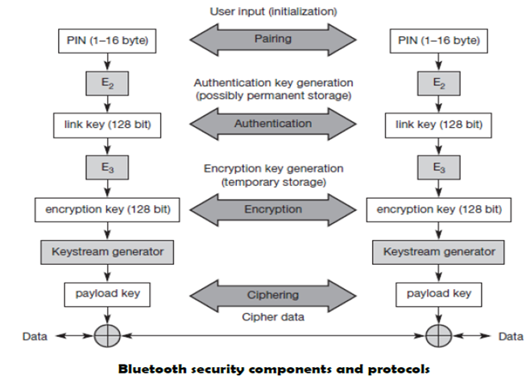**Introduction:** The main security features offered by Bluetooth include a challenge response routine for authentication, a stream cipher for encryption, and a session key generation. Each connection may require a one-way, two-way, or no authentication using the challenge-response routine. The security algorithms use the public identity of a device, a secret private user key, and an internally generated random key as input parameters. For each transaction, a new random number is generated on the Bluetooth chip. Key management is left to higher layer software.

**The following figure shows several steps in the security architecture of Bluetooth.**

The first step, called **pairing**, is necessary if two Bluetooth devices have never met before. To set up trust between the two devices a user can enter a secret PIN into both devices. This PIN can have a length of up to 16 byte. Based on the PIN, the device address, and random numbers, several keys can be computed which can be used as link key for **authentication**. The authentication is a challenge-response process based on the link key, a random number generated by a verifier (the device that requests authentication), and the device address of the claimat (the device that is authenticated).

Based on the link key, and again a random number an encryption key is generated during the encryption stage of the security architecture. This key has a maximum size of 128 bits and can be individually generated for each transmission. Based on the encryption key, the device address and the current clock a payload key is generated for ciphering user data. The payload key is a stream of pseudo-random bits. The ciphering process is a simple XOR of the user data and the payload key.

All Bluetooth-enabled devices must implement the Generic Access Profile, which contains all the Bluetooth protocols and possible devices. This profile defines a security model that includes three security modes:

1.       Mode 1 is an insecure mode of operation. No security procedures are initiated.

2.       Mode 2 is known as service-level enforced security. When devices operate in this mode, no security procedures are initiated before the channel is established. This mode enables applications to have different access policies and run them in parallel.

3.       Mode 3 is known as link-level enforced security. In this mode, security procedures are initiated before link setup is complete.

Though Bluetooth offers a better security than WER in 802.11, it has several limitations. The PIN’s are often fixed and some keys are permanently stored on the devices. The quality of the random number generators has not been specified.

**SDP (service discovery protocol)**

**Introduction:** To find new services available in the radio proximity, Bluetooth defined the **service discovery protocol (SDP)**. SDP defines only the discovery of services, not their usage. Discovered services can be cached and gradual discovery is possible. All the information an SDP server has about a service is contained in a **service record**. This consists of a list of service attributes and is identified by a 32-bit service record handle.

A service attribute consists of an attribute ID and an attribute value. The 16-bit attribute ID distinguishes each service attribute from other service attributes within a service record. The attribute ID also identifies the semantics of the associated attribute value. The attribute value can be an integer, a UUID (universally unique identifier), a string, a Boolean, a URL (uniform resource locator) etc.

**Bluetooth Profiles**

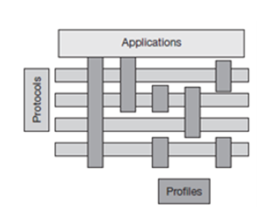Bluetooth profiles are intended to ensure interoperability among Bluetooth-enabled devices and applications from different manufacturers and vendors. A profile defines the roles and capabilities for specific types of applications. Profiles represent default solutions for a certain usage model. They use a selection of protocols and parameter set to form a basis for interoperability. Protocols can be seen as horizontal layers while profiles are vertical slices as shown below:

The following **basic profiles**have been specified: generic access, service discovery, cordless telephony, intercom, serial port, headset, dialup networking, fax, LAN access, generic object exchange, object push, file transfer, and synchronization. **Additional profiles**are: advanced audio distribution, PAN, audio video remote control, basic printing, basic imaging, extended service discovery, generic audio video distribution, hands-free, and hardcopy cable replacement. Some of the profiles are given below:

**The *Generic Access Profile***defines connection procedures, device discovery, and link management. It also defines procedures related to use of different security models and common format requirements for parameters accessible on the user interface level. At a minimum all Bluetooth devices must support this profile.

**The *Service Discovery Application and****Profile*defines the features and procedures for an application in a Bluetooth device to discover services registered in other Bluetooth devices, and retrieves information related to the services.

**The *Serial Port Profile***defines the requirements for Bluetooth devices that need to set up connections that emulate serial cables and use the RFCOMM protocol.

**The *LAN Access Profile***defines how Bluetooth devices can access the services of a LAN using PPP, and shows how PPP mechanisms can be used to form a network consisting of Bluetooth devices.

The Synchronization Profile defines the application requirements for Bluetooth devices that need to synchronize data on two or more devices.